PARTICIPANT PROFILE
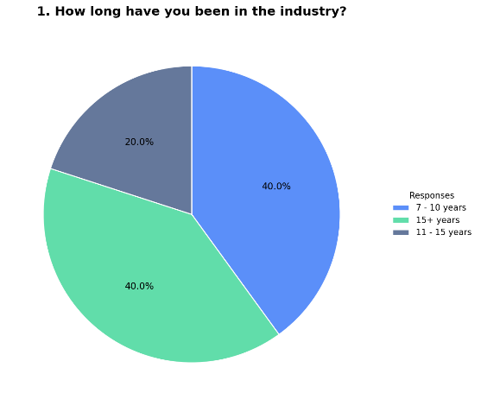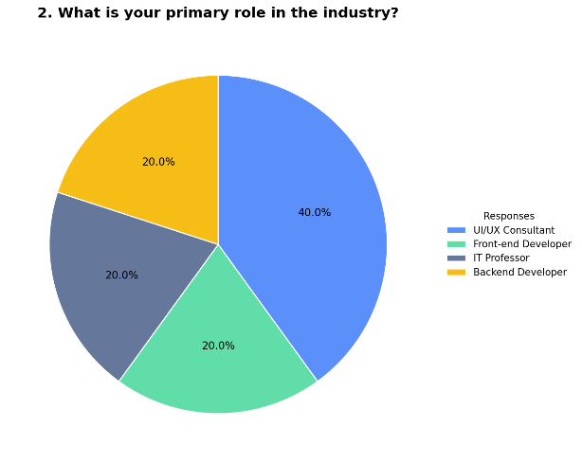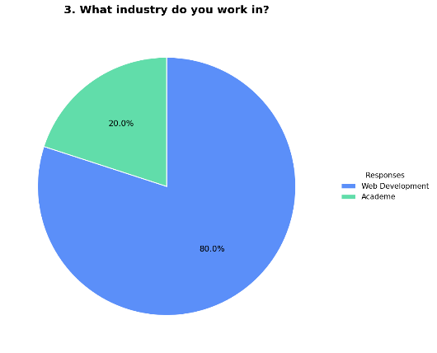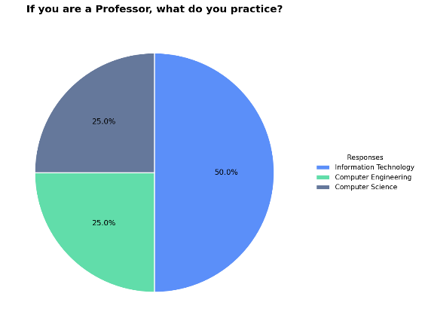
The participant profile indicates that the majority of respondents possess substantial industry experience, with most having between 7 to 15 years in the field, which reflects a highly experienced group of evaluators. In terms of role distribution, the largest portion consists of UI/UX consultants, followed by front-end developers, IT professionals, and backend developers, resulting in a diverse set of perspectives related to system usability and interface design. Additionally, most respondents are from the web development industry, with a smaller portion from academia, which suggests that the evaluation is grounded primarily in practical, industry-based experience. For respondents involved in academia, their areas of specialization include Information Technology, Computer Engineering, and Computer Science, which further supports the credibility of the evaluation due to their technical background.

INTERFACE DESIGN
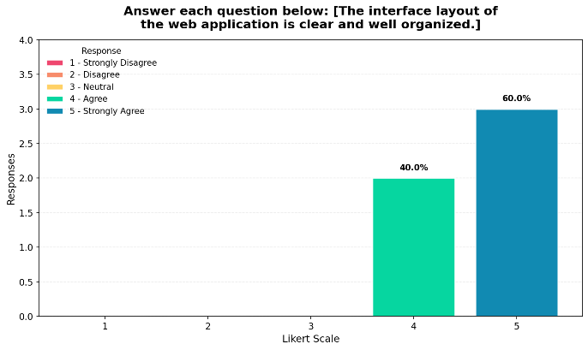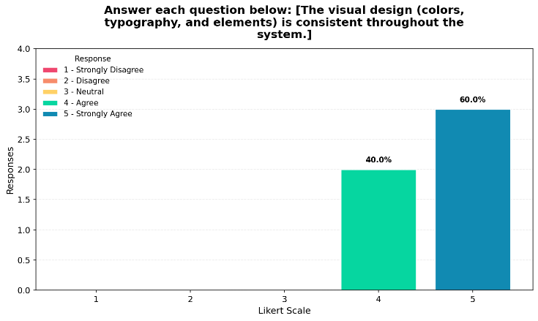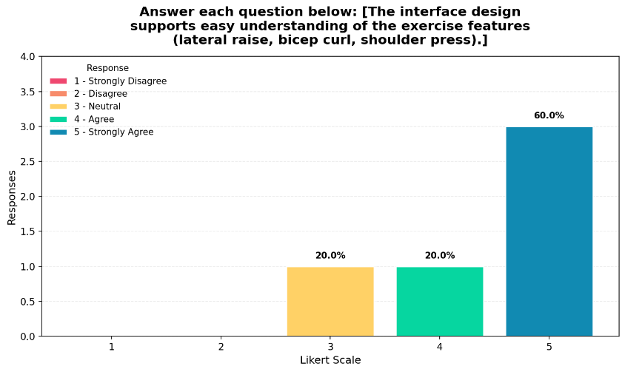
The results for interface design show that the majority of responses are concentrated at values 4 and 5, which indicates that participants generally agree that the system’s interface is clear, consistent, and easy to understand. The layout of the web application was perceived as well-organized, while the visual design elements such as colors and typography were considered consistent throughout the system. Additionally, most respondents strongly agreed that the interface supports easy understanding of exercise features, although a small portion of neutral responses suggests that some users may require minor improvements in clarity. Overall, these results indicate that the system’s interface design is effective in supporting user interaction and comprehension.

USABILITY / NAVIGATION
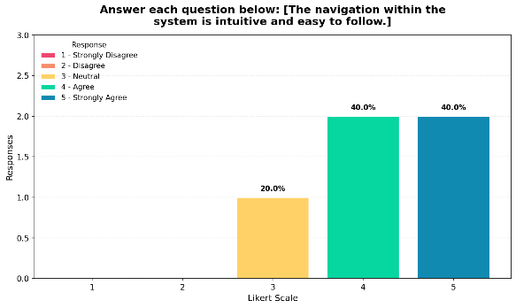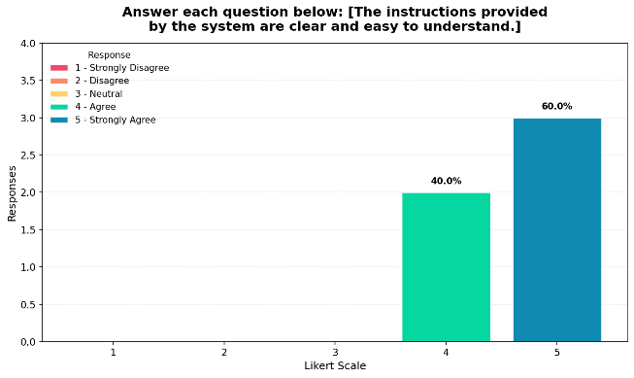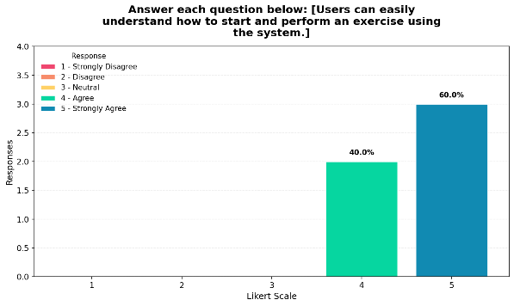
The responses for usability indicate that most participants selected values between 4 and 5, which means that the system is generally easy to navigate and understand. The navigation was perceived as intuitive, allowing users to move through the system with minimal difficulty, while the instructions provided were considered clear and easy to follow. Furthermore, respondents strongly agreed that users can easily understand how to start and perform exercises using the system, which suggests that the learning curve is low. Although a small number of neutral responses were observed, the overall trend indicates that the system effectively supports user interaction and usability.

SYSTEM PERFORMANCE

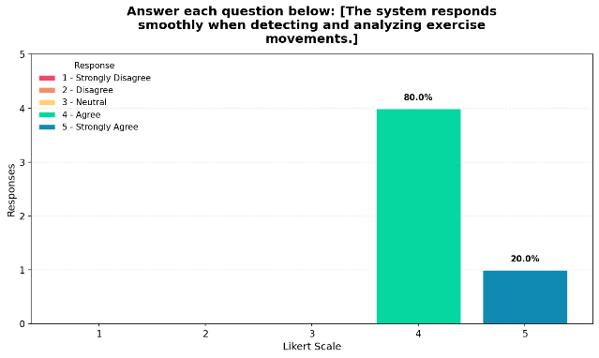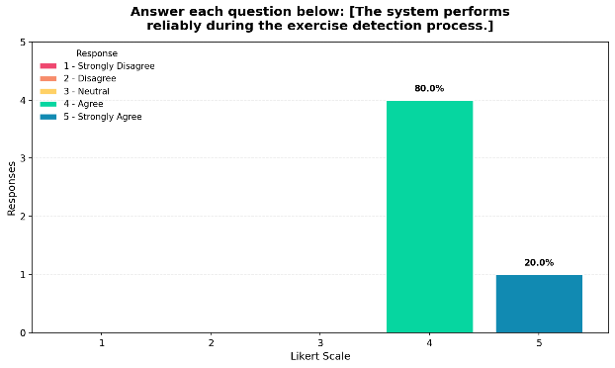
The results for system performance indicate that the majority of responses fall within the “Agree” category, with some responses reaching “Strongly Agree,” which means that the system performs consistently and responds smoothly during exercise detection and analysis. Most participants perceived the system as stable and reliable, with no negative responses recorded. This suggests that the system is capable of maintaining performance during real-time operation, although the concentration of responses at value 4 rather than 5 may indicate that there is still room for further optimization in responsiveness and reliability.

FEEDBACK EFFECTIVENESS
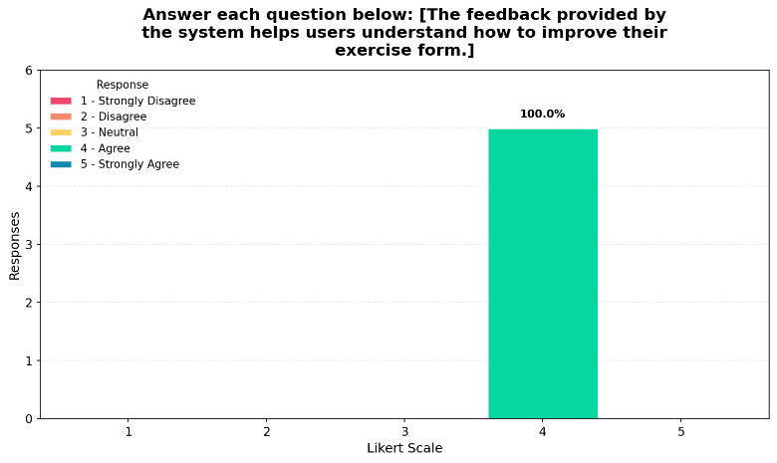
The responses for this item show that all participants selected value 4, resulting in a 100% agreement rate that the feedback provided by the system helps users understand how to improve their exercise form. This indicates that the system is effective in delivering meaningful and actionable feedback, although the absence of “Strongly Agree” responses may suggest that while the feedback is useful, there is still potential to enhance its clarity or depth for expert-level users.
OVERALL EXPERIENCE & INTEGRATION
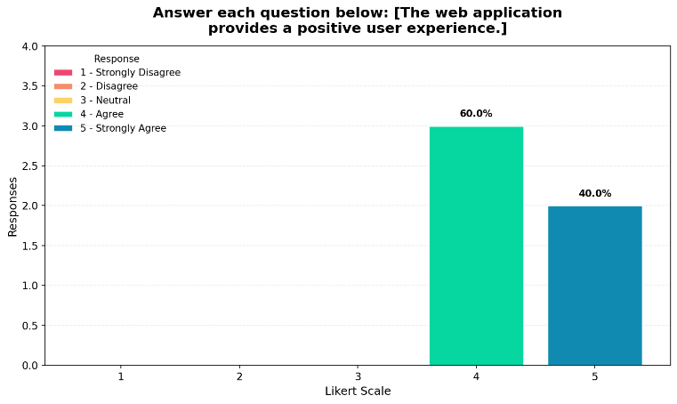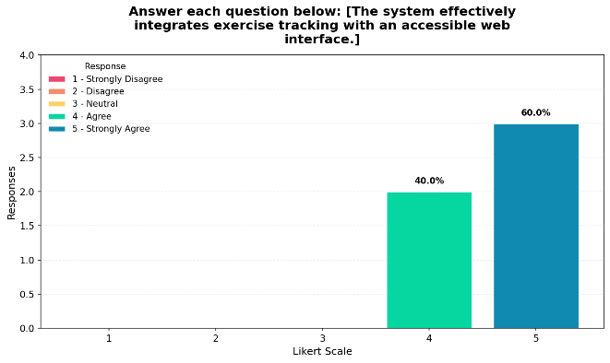The results for overall experience indicate that most participants selected values between 4 and 5, which suggests that the web application provides a generally positive user experience. Respondents agreed that the system effectively integrates exercise tracking with an accessible web interface, making it usable and cohesive as a complete system. The presence of both “Agree” and “Strongly Agree” responses indicates that while the system performs well overall, there are still opportunities for refinement to achieve a more optimal user experience.

RECOMMENDATION BEFORE DEPLOYMENT
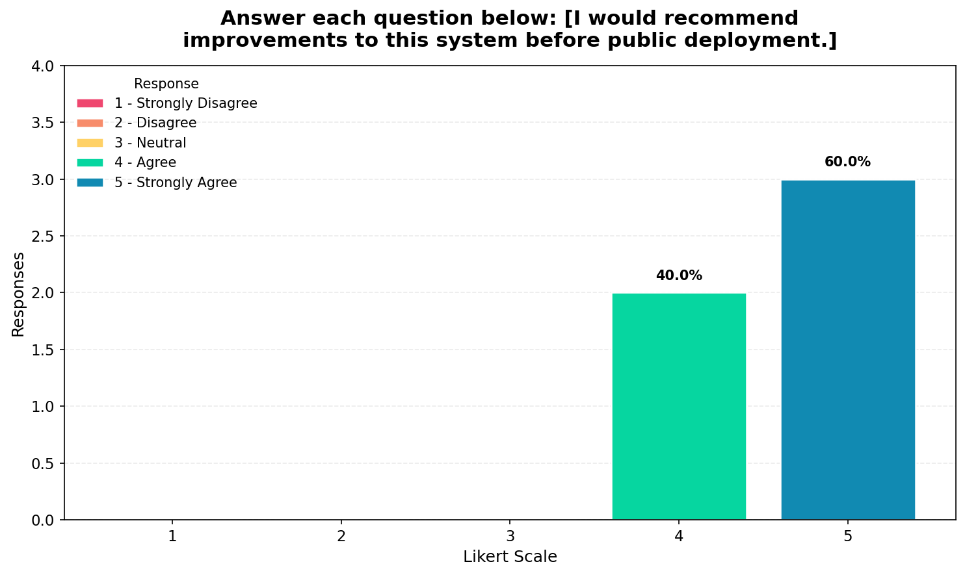The responses for this item show that the majority of participants selected values 4 and 5, which indicates that while the system is generally well-received, industry experts recommend that improvements should still be made before public deployment. This suggests that although the system is functional and effective, further refinements are necessary to meet professional standards, particularly in terms of usability, performance optimization, or feature completeness.

